5.3 Independence of Path; Conservative Vector Field Worksheet

- Find , where and C is the curve from to .

- Consider the vector field .
- Compute where C is the curve moving from to in .

- Construct two different paths that would connect the points and in .

- Determine if F is independent of path.

- Determine if each of the following statements is TRUE or FALSE:
- The union of two simply connected domains is connected.

- If a differentiable vector field F satisfies for every closed path C in an open, connected domain D, then there always exists a function f such that on D.

- If a differentiable vector field satisfies on a connected domain D, then F is conservative on D.

- If for some closed path C, then F must be a conservative vector field.

- Consider the vector field.
- Find a function f on whose gradient is F.

- Compute the line integral , where C is a line segment from to .

- Let . Determine whether F is a conservative vector field. If it is, find its potential function.

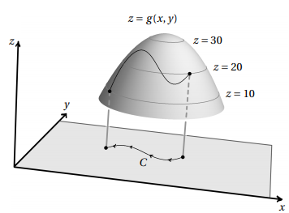
- Let be the function whose graph is shown at the right, and let C be the indicated curve in the xy-plane. Using only this information evaluate the line integral .

- Consider the vector field on .
- Show that F is conservative by finding its potential function .

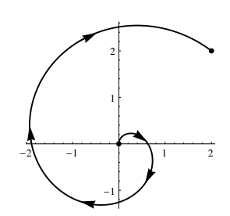
- For the curve C shown at the right, evaluate .

- Consider the curve C which is a straight-line segment from to .
- For , compute .

- For , compute .

- Circle the best estimate for .
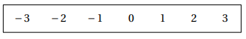

- Let be the vector field defined by .
- Let C be the unit circle oriented counterclockwise. Show that . (You will need to split the integral into two pieces).

b) It turns out that is true for any closed curve C in the plane and not just the unit circle. But, this vector field is not conservative. Explain why this vector field cannot be conservative.

- Let D be the set of all point in except for . In each part below, indicate whether a continuous vector field with domain D and the property described is necessarily conservative or not necessarily conservative. (If the vector field is never conservative, circle not necessarily conservative.)

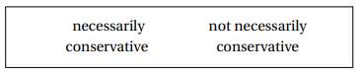
- .

is

- has the path independence property; that is, the line integral is independent in D.

is

- where over D.


is

- has the property that for the unit circle (given by ), .

is

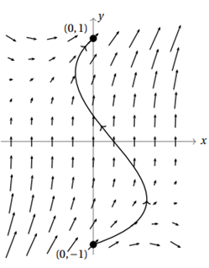
- A continuous vector field F, defined on , is shown at the right. For the sake of understanding the scale in this picture let . Assuming that F is conservative, circle the value of , where C is the curve shown from to .
